Celebration of the life of Linda Smart.
Posted 23rd February 2021
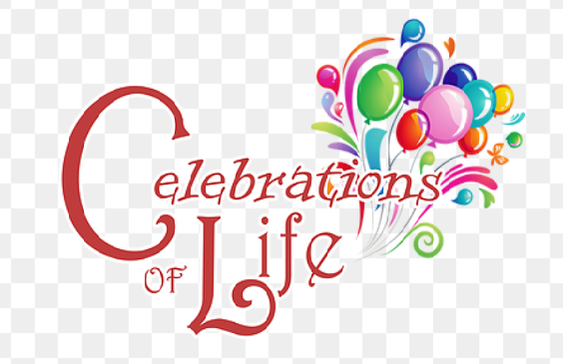
Sadly, Lynn Lost Her Fight with “Motor Neurone Disease” (MND) 12th October 2020, to Celebrate Lynn Life, I have booked the village hall (Boughton Monchelsea), 6.00pm till 10.00pm.
This is your personal invitation.
please join us 18th September 2021.
Please let me know ASAP, this new date is our wedding anniversary, 17th September2021.


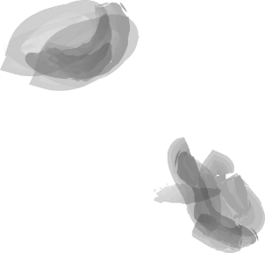
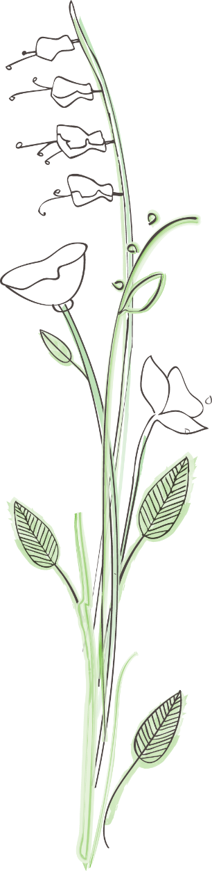
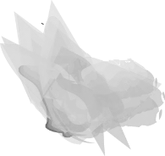
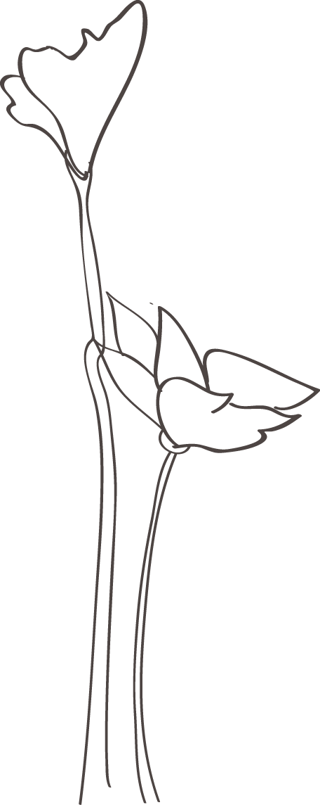
Looking forward to seeing you all, much love from
Dave, Rachel, Rebecca, Dan and Elysia xxxxx

